Digital Ad Revenue Gains Remain Elusive for Magazines and Newspapers
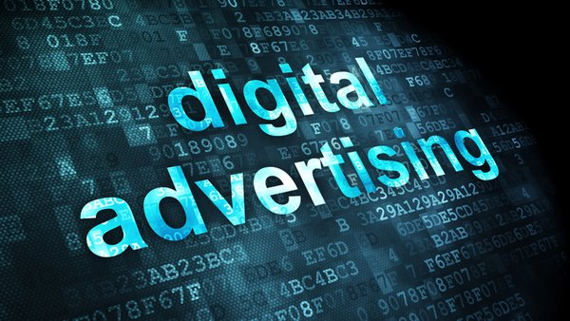
The companies reaping the greatest shares of digital ad revenues—Google, Facebook and Amazon—are tech-driven, nontraditional publishers that have cracked the code for digital advertising. Meanwhile, newspapers and magazines have struggled to increase digital ad earnings for years.
eMarketer 4.10.19
https://www.emarketer.com/content/digital-ad-revenue-gains-remain-elusive-for-magazines-and-newspapers?ecid=NL1001
Image credit:
http://techstory.in/wp-content/uploads/2016/04/CdrIarHWwAMctbP.jpg

