Forecast: US Digital Ad Spend to Pass Traditional
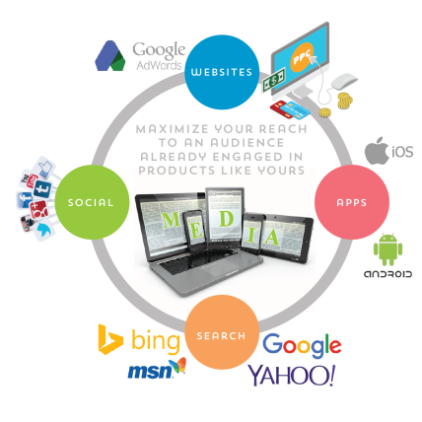
US digital ad investment will hit $129.34 billion in 2019, up 19%, taking a 54.2% share of overall estimated ad spend, according to eMarketer. Mobile will make up more than two-thirds of digital ad investment, and while Google and Facebook continue to dominate, Amazon's share in third place will rise from 6.8% in 2018 to 8.8% this year.
eMarketer 2/19/19
https://www.emarketer.com/content/us-digital-ad-spending-will-surpass-traditional-in-2019
Image credit:
http://www.kolmg.com/wp-content/uploads/2014/05/DigitalCircle.png

