Digital Ad Trends to Watch
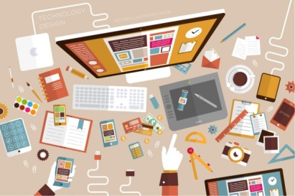
At a recent IAB conference, influencers, marketing leaders and other professionals examined the tools and technologies that today's digital marketers need to heed. Krystle Davis shares highlights, including the increased reliance on influencers; emerging technology such as 5K, advancements in OTT, connected TV, voice and video; and direct-to-consumer budget shifts toward digital marketing spend.
Forbes 5/28/19
https://www.forbes.com/sites/forbescontentmarketing/2019/05/28/digital-advertising-trends-to-watch-in-2019-and-beyond/#62ddea5ce1ee
Image credit:
http://www.pfhub.com/wp-content/uploads/2014/09/digital-advertising.jpg

