Digital Ads Are Relevant For 44% Of Consumers
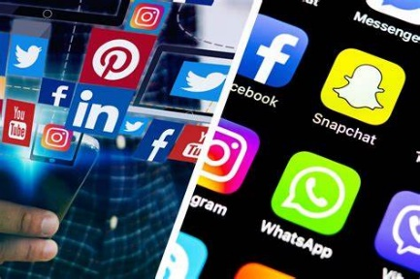
Most digital ads that 44% of adults saw in 2023 were somewhat or very related to their lives and interests, a CivicScience poll revealed, up from 37% in 2022. While the jury's out on whether targeting is getting better or people are just viewing more ads, relevant marketing makes 59% of people likely to click.
CivicScience 1/18/23
https://civicscience.com/digital-ads-continue-to-become-more-relevant-to-consumers/
Image copyright:
https://filmlifestyle.com/wp-content/uploads/2022/06/Best-Digital-Advertising-Platforms52.jpg

