Digital Ads Come to College Vending Machines
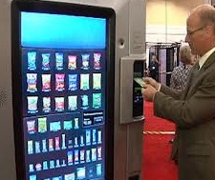
Blackstone LaunchPad has teamed with Vengo Labs to roll out vending machines that display digital ads on college campuses. The ads could tout products available in the kiosks and will give marketers real-time data.
Adweek 6/3/16
http://www.adweek.com/news/technology/innovative-college-vending-machines-will-feature-digital-ad-network-171807

