US Digital Divide Is Getting Smaller, FCC Report Says
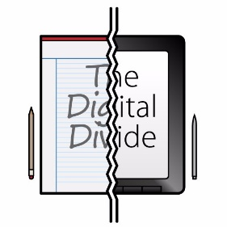
The Federal Communications Commission's yearly Broadband Deployment Report shows that almost 83% of rural Americans had access to broadband service when 2019 ended. Ajit Pai, the agency's outgoing chairman, is proud of the FCC's progress in "closing the digital divide."
Advanced Television (free registration) 1/19/21
https://advanced-television.com/2021/01/20/report-us-digital-divide-closing/
Image credit:
https://www.chilmarkresearch.com/wp-content/uploads/2017/12/digital_divide.jpg

