Digital Push Calls on FTC to Break up Facebook
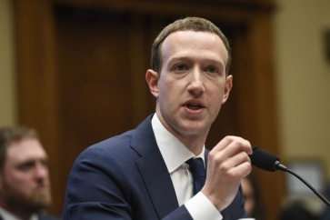
A host of advocacy groups -- including Demand Progress, SumOfUs, the Content Creators Coalition, Citizens Against Monopoly, Jewish Voice for Peace, MoveOn Civic Action, MPower Change and the Open Markets Institute -- are behind the Freedom From Facebook initiative calling on the Federal Trade Commission to divide up Facebook and its subsidiaries WhatsApp, Messenger and Instagram.
MediaPost Communications 5/21/18
https://www.mediapost.com/publications/article/319554/liberal-critics-of-facebook-want-spinoff-of-compan.html
Image credit:
https://www.cheatsheet.com/wp-content/uploads/2018/04/Mark-Zuckerberg-testifying.jpg?x23912

