DirecTV Loses An Estimated 400,000 Subscribers In Q2
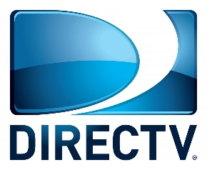
According to Leichtman Research Group's recent tally of pay TV subscribers, DirecTV has around 13.9 million remaining subscribers. This is around 12 million fewer than existed between DirecTV satellite and U-verse back in May 2014, when AT&T agreed to pay $49 billion to buy DirecTV and -- briefly -- usurped Comcast to become the nation's No. 1 pay TV operator.
Next TV 8.12.22
https://www.nexttv.com/news/directv-loses-an-estimated-400000-subscribers-in-q2-as-base-dips-below-14-million?utm_source=SmartBrief&utm_medium=email&utm_campaign=C74FC4FA-5D4D-4151-8915-3043BA411DBE&utm_content=19C74584-CAFE-40C8-8BCB-23B14CC391F5&utm_term=a25693a1-51b6-4112-bde4-56bd420e983f

