Opinion: Disappearance of Public Papers Hurts Local News
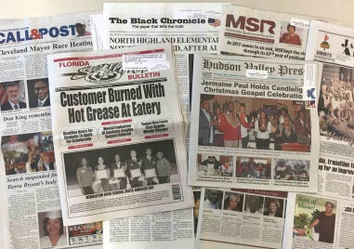
The number of publicly-owned newspapers has shrunk dramatically in the last two decades, and potential Tribune and McClatchy acquisitions this week would diminish that figure further. The increasing control profit-driven hedge funds wield over the newspaper industry is contributing to the downfall of local outlets, Rick Edmonds contends.
Poynter 6/30/20
https://www.poynter.org/locally/2020/disappearing-public-newspaper-companies-were-a-thriving-group-not-so-long-ago/
Image credit:
https://www.princeton.edu/sites/default/files/styles/half_2x/public/images/2018/09/IMG_2694.jpg?itok=izsLAjAe

