Discovery-WarnerMedia Deal Gets Key Antitrust Clearance
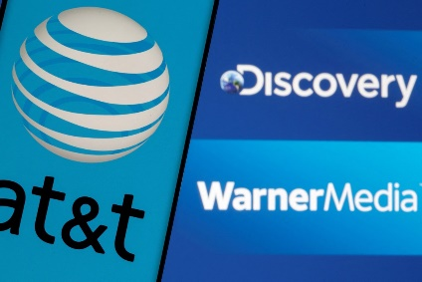
US antitrust regulators have cleared the proposed $43 billion Discovery-WarnerMedia merger, Discovery revealed in a government filing that says the waiting period for agencies to act under a 1976 antitrust law has expired. The deal still requires Discovery shareholder approval, but WarnerMedia parent AT&T does not need to act, so it's very likely to close before the end of June.
The Hollywood Reporter 2/9/22
https://www.hollywoodreporter.com/business/business-news/discovery-warnermedia-merger-gets-u-s-antitrust-clearance-1235089790/

