Another One! 37 Hearst Stations Blacked Out on Dish Network
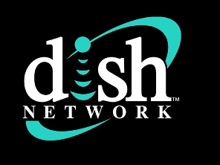
The pay TV market was hit with yet another significant program licensing impasse Friday when Dish Network announced that broadcaster Hearst Television has pulled 37 of its network affiliates in 27 markets off of Dish's program guide.
TV Tech 9.8.23
https://www.tvtechnology.com/news/hearst-stations-blacked-out-on-dish?utm_term=A25693A1-51B6-4112-BDE4-56BD420E983F&utm_campaign=C74FC4FA-5D4D-4151-8915-3043BA411DBE&utm_medium=email&utm_content=20994922-BE5C-486D-8E03-22E7096E3D85&utm_source=SmartBrief

