Disinformation’s Spread: Bots, Trolls and All Of Us
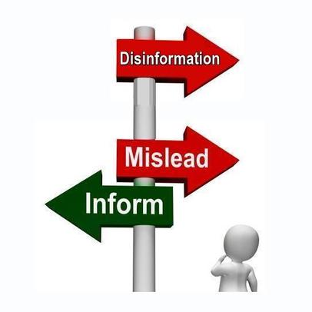
But disinformation is not as cut-and-dried as most people assume: those behind disinformation campaigns purposely entangle orchestrated action with organic activity. Audiences become willing but unwitting collaborators, helping to achieve campaigners’ goals. This complicates efforts to defend online spaces.
Nature 7.24.19
https://www.nature.com/articles/d41586-019-02235-x
Image credit:
https://endtimesprophecyreport.files.wordpress.com/2016/06/disinformation.jpg

