Disney Buys Big Chunk of Fox In $66.1B Deal
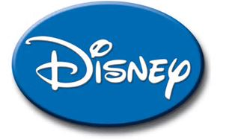
The Walt Disney Co. this morning announced its acquisition of a major portion of 21st Century Fox in a deal that dramatically positions Disney for the future. Before the buyout, 21st Century Fox will separate the Fox Broadcasting network and stations, Fox News Channel, Fox Business Network, FS1, FS2 and Big Ten Network into a newly listed company that will be spun off to its shareholders.
The Associated Press 12.14.17
http://www.tvnewscheck.com/article/109662/disney-buys-big-chunk-of-fox-in-661b-deal?utm_source=Listrak&utm_medium=Email&utm_term=Disney+Buys+Big+Chunk+Of+Fox+In+%2466.1B+Deal&utm_campaign=Disney+Buys+Big+Chunk+Of+Fox+In+%2466.1B+Deal

