Disney Closes $71B Deal for Fox Assets
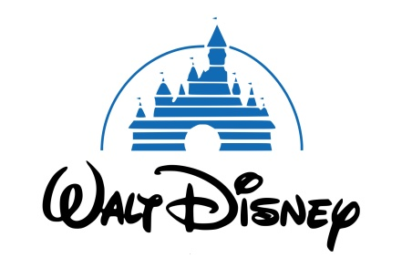
The deal is likely to shake up the media landscape. Among other things, it paves the way for Disney to launch its streaming service, Disney Plus, due out later this year. It will also likely lead to layoffs in the thousands, thanks to duplication in Fox and Disney film-production staff.
TVNewsCheck 3.20.19
https://tvnewscheck.com/article/top-news/232369/disney-closes-71b-deal-for-fox-assets/?utm_source=Listrak&utm_medium=Email&utm_term=Disney+Closes+%2471B+Deal+For+Fox+Assets&utm_campaign=Big+Money+Pours+In+For+B-Ball%27s+Big+Dance

