Disney Offers $71B for Fox Assets
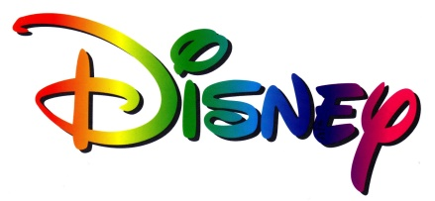
Disney has formally submitted a $71.3 billion bid for 21st Century Fox assets -- a cash-and-stock offer valued at $85.1 billion, including debt. The move comes as Fox's board is to meet today to discuss Comcast's $65 billion bid for the entertainment assets.
Deadline Hollywood 6/20/18
https://deadline.com/2018/06/disney-fox-merger-increased-bid-in-wake-of-comcast-offer-1202414080/

