Disney Releases In-Theater AR Game
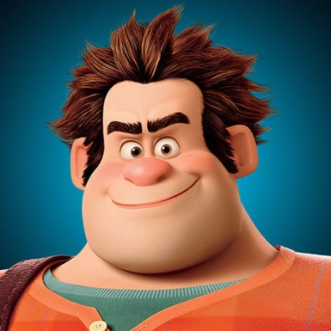
Disney has created an augmented reality game, "Wreck-It Ralph," available for moviegoers to play in theaters prior to the start of a movie. The game will be available in 1,700 theaters nationwide as a promotion for Disney's upcoming movie "Ralph Breaks the Internet."
MediaPost Communications 11/1/18
https://www.mediapost.com/publications/article/327399/disney-campaign-for-ralph-breaks-the-internet-bo.html
Image credit:
http://img.lum.dolimg.com/v1/images/ralph-headretina_f6ef0c9b.jpeg?region=0,0,450,450

