Disney Sets Comcast's Hulu Stake Value At $8.6B
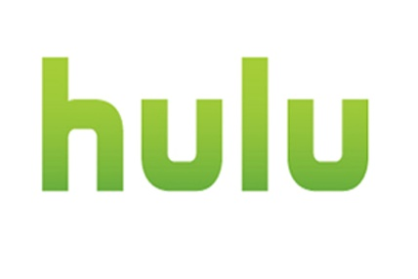
Disney will pay Comcast a minimum of $8.61 billion to buy out NBCUniversal's 33% share of Hulu, but could end up paying more as the parties negotiate the streaming service's total value. Comcast, which exercised its option to sell the stake, maintains that Hulu is worth more than its $27.5 billion floor value that was set in 2019.
Variety 11/1/23
https://variety.com/2023/digital/news/disney-buys-hulu-stake-comcast-1235776557/

