DOJ Starts Antitrust Probe Of Big Tech Firms
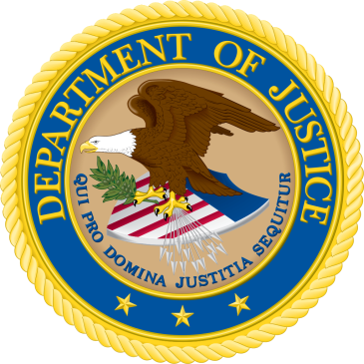
The antitrust division of the Department of Justice launched a review into how big tech firms involved in search, social media and some online retail services have grown and whether their business practices hamper competition or hurt consumers, which appears to be a direct target at Google, Facebook and Amazon.
TechCrunch 7/24/19
https://techcrunch.com/2019/07/23/doj-announces-investigation-into-big-tech/

