Why DoorDash Believes Gaming Partnerships Deliver
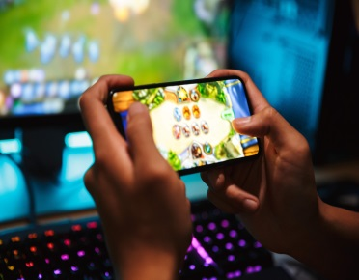
DoorDash is working to boost delivery orders among Gen Z and millennial customers by tapping into the gaming community with efforts such as its two-day Battle of the Snacks on Twitch and NBA 2K League presenting partnership. "[W]e strive to find ways to authentically engage with new audiences by meeting them where they are, and the connection between gaming and food felt like a natural fit for us," said Katie Daire, DoorDash's senior director of consumer marketing.
Adweek 11/11/21
https://www.adweek.com/brand-marketing/doordash-gaming-twitch-esports-reach-gen-z-millennials/
Image credit:
https://images.indulgexpress.com/uploads/user/imagelibrary/2019/12/30/original/OnlinegaminginIndia.jpg

