Dordt University’s KDCR To Cease Operations In Wake Of Sale To EMF
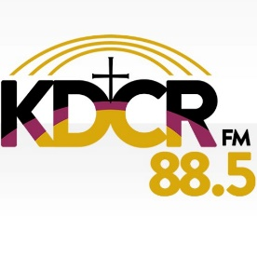
Dordt University is selling contemporary Christian KDCR Sioux Center, IA (88.5) to Educational Media Foundation and will cease operating the station May 15, when EMF will place its “K-Love” format on the signal via a lease agreement. The University says the decision to sell the station, which it has operated since 1968, was fueled by ongoing costs and limited financial support.
Inside Radio 3.23.21
http://www.insideradio.com/free/dordt-university-s-kdcr-to-cease-operations-in-wake-of-sale-to-emf/article_2a04311c-8bd9-11eb-aaee-e39491996b16.html
Image credit:
https://pbs.twimg.com/profile_images/797123418688626688/5ZshIxY-.jpg

