E-Cigarette Ad Regulating Stirs Debate at FCC
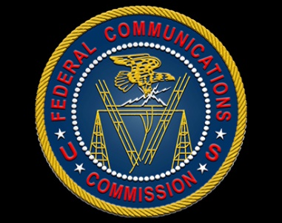
Commissioner Brendan Carr of the Federal Communications Commission is skeptical of regulating e-cigarette advertising, tweeting that the government should not restrict lawful speech merely because it disagrees with the content. He shared his perspective in response to fellow Commissioner Jessica Rosenworcel's call for increased oversight.
Inside Radio 2/20/19
http://www.insideradio.com/free/debate-emerges-at-fcc-over-its-role-to-regulate-e/article_481152ec-34de-11e9-90b9-e70d0fbfd987.html

