Emmanuel Macron Promises Ban on Fake News During Elections
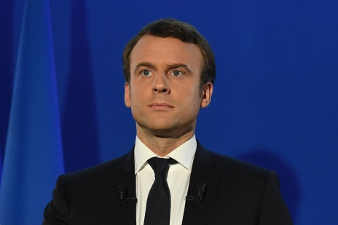
For fake news published during election seasons, an emergency legal action could allow authorities to remove that content or even block the website, Macron said. “If we want to protect liberal democracies, we must be strong and have clear rules,” he added.
The Guardian 1.3.18
https://www.theguardian.com/world/2018/jan/03/emmanuel-macron-ban-fake-news-french-president?utm_source=API+Need+to+Know+newsletter&utm_campaign=4a85c286ca-EMAIL_CAMPAIGN_2018_01_04&utm_medium=email&utm_term=0_e3bf78af04-4a85c286ca-31697553
Image source:
https://www.bing.com/images/search?view=detailV2&ccid=mwxwdGnl&id=EB49599F5097B07575072B917ECA507D8D4C21B9&thid=OIP.mwxwdGnlGonmmPHvUIkdbgEyDM&mediaurl=http%3a%2f%2fd.ibtimes.co.uk%2fen%2ffull%2f1611396%2femmanuel-macron.jpg&exph=1067&expw=1600&q=MACRON&simid=608048898774663252&selectedIndex=17&ajaxhist=0

