Ending Copyright Act Would Change Internet
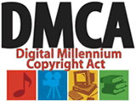
Every day we turn to the Internet for the seemingly endless amount of information and entertainment it provides. Despite the creative and economic value the Digital Millennium Copyright Act has helped create, the copyright industry wants to radically change the law to force online platforms to police for copyright infringements on their behalf by using content filtering technology.
The Hill 3.28.17
http://thehill.com/blogs/pundits-blog/technology/326043-ending-digital-copyright-act-would-fundamentally-change

