Engage with Social Communities Amid Crisis
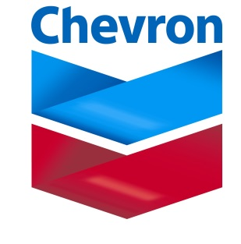
Chevron Social Media Manager Olivia Harting recommends continuing to engage social media communities amid crises, such as the refinery accidents and Twitter hijackings that have challenged her brand. Create a social media playbook with a team of advisers and use paid search ads to direct consumers to owned media for updates.
SmartBrief/Marketing 10/19/16
http://www.smartbrief.com/original/2016/10/how-chevron-leverages-social-media-crisis?utm_source=brief

