EPIX, Starz Expand TV Everywhere Apps
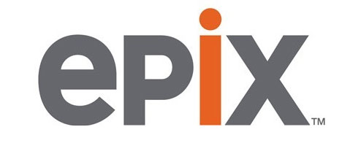
EPIX and Starz have each expanded their TV Everywhere applications. EPIX unveiled an app for Google's Android TV system that features live streams from four networks, a wide selection of video-on-demand titles and movie trailers. The Starz app, which includes about 300 movies and more than 150 episodes from original series, is now available on the Amazon Fire TV box and Fire TV Stick.
Multichannel News 6/19/15
http://www.multichannel.com/news/next-tv/epix-launches-android-tv-app/391559

