For Reporters in Mexico, Journalist's Death Underscores Job's Growing Danger
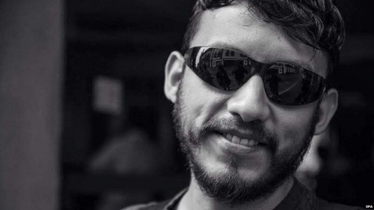
Ruben Espinosa, 31, was the 12th journalist who worked in the state of Veracruz to be killed since 2011. Espinosa, who worked for a number of respected Mexican newsmagazines, including Proceso and Cuarto Oscuro, specialized in covering social movements and was involved in protests seeking justice for the journalists killed in Veracruz. He fled the state on Mexico’s east coast in early June after being harassed, later telling the Mexican political website SinEmbargo that his house had been under surveillance.
Los Angeles Times 8.3.15
http://www.latimes.com/world/mexico-americas/la-fg-mexico-city-safety-death-20150802-story.html?utm_source=API%27s+Need+to+Know+newsletter&utm_campaign=783394d53e-Need_to_Know_August_4_20158_4_2015&utm_medium=email&utm_term=0_e3bf78af04-783394d53e-31697553

