ESPN Suspends Jemele Hill Over Social Media Use
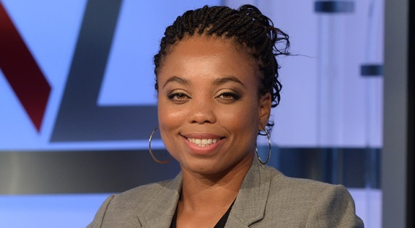
"Jemele Hill has been suspended for two weeks for a second violation of our social media guidelines. She previously acknowledged letting her colleagues and company down with an impulsive tweet. In the aftermath, all employees were reminded of how individual tweets may reflect negatively on ESPN and that such actions would have consequences. Hence this decision," reads an ESPN statement.
The Hollywood Reporter 10.10.17
http://www.hollywoodreporter.com/news/espn-suspends-jemele-hill-social-media-use-1047149
Image credit:
https://dodoodad.com/wp-content/uploads/2016/02/jemele-hill.jpg

