Esports Viewership On The Rise, Up 9% In 2023
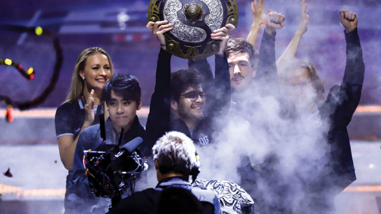
According to yearly livestreaming trends report from FaZe Clan owner GameSquare‘s streaming analytics platform Stream Hatchet, 2.5 billion hours of esports events were watched last year. That data includes a wide array of esports rather than just mainstream events, which in part contributes to the year-over-year growth.
Variety 2.15.24
https://variety.com/2024/gaming/news/esports-viewership-study-livestreaming-gamesquare-1235911403/
Image copyright:
https://www.esportsbets.com/wp-content/uploads/2019/09/esports-on-tv.jpg

