EU Proposed Privacy Law Will Kill Digital Media
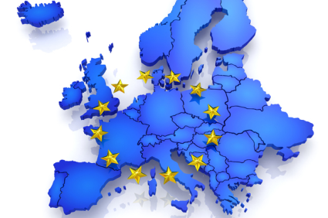
The European Union's ePrivacy Regulation poses a global threat to the digital media economy, requiring publishers to serve online content to consumers even if they block advertising, writes the Interactive Advertising Bureau's Randall Rothenberg. "The impact in the mobile environment, where the majority of mobile applications depend on advertising revenue to survive, would be just as devastating," he writes.
Business Insider 8/14/17
http://www.businessinsider.com/european-regulators-are-about-to-kill-the-digital-media-industry-2017-8
Image credit:
http://static1.squarespace.com/static/56eddde762cd9413e151ac92/570cb87b5bd33022b93a0272/5891c70dd482e9c23b9a7ce5/1486018912334/eu.jpg?format=1000w

