Evan Rachel Wood finally gets equal pay on "Westworld"
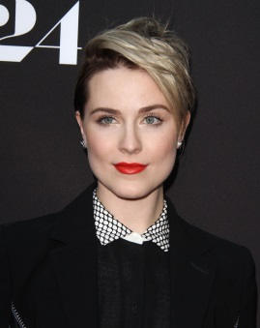
Evan Rachel Wood of HBO's "Westworld" said for the first time in her career she will receive the same pay as her male co-stars. "I think now we're all doing equal amounts of work and really hard work, “Wood said, acknowledging HBO's equal pay initiative.
TheWrap 4/18/18

https://www.thewrap.com/evan-rachel-wood-westworld-equal-pay-male-co-stars-season-3-video/
Image credit:
http://celebmafia.com/wp-content/uploads/2016/06/evan-rachel-wood-a24-s-into-the-forest-premiere-at-arclight-hollywood-in-hollywood-1.jpg

