Every State Has Signed Up For Broadband Funding Plans
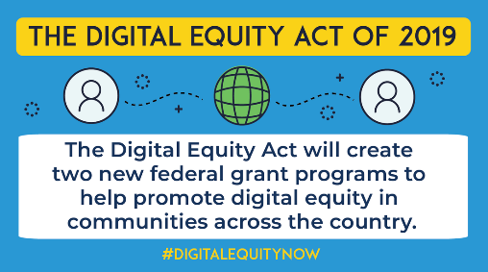
The Department of Commerce has received letters of intent from every state and eligible territory, indicating that they will take part in both the Broadband Equity Access and Deployment initiative and the State Digital Equity Planning Grant Program. States must still assign federally approved agencies to oversee the grants.
Telecompetitor 7/13/22
https://www.telecompetitor.com/all-50-states-on-board-for-bead-digital-equity-broadband-funding-programs/
Image credit:
https://www.techgoeshomecha.org/uploads/4/6/5/6/46566799/digital-equity-grant-programs-twitter_orig.png

