Every TV channel should "stand up on its own," AMC Networks CEO says
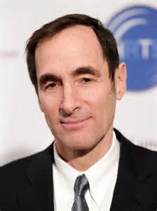
TV networks, given cord-cutting and other changes in the TV industry, must be prepared for an era of "greater accountability for the life and price of every channel that is carried in the system," AMC Networks CEO Josh Sapan said at an industry event. "We're true believers that every channel should stand up on its own, be valuable, be priced well," Sapan said.
The Hollywood Reporter 12/7/15
http://www.hollywoodreporter.com/news/amc-networks-ceo-tv-industry-846328

