Facebook Bans ‘Dangerous Individuals’
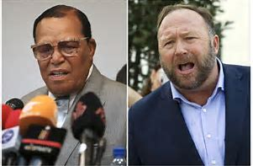
Decried as censorship by several of those who got the ax, including Louis Farrakhan, Alex Jones and other extremists, the move signals a renewed effort by the social media giant to remove people and groups promoting objectionable material such as hate, racism and anti-Semitism.
TVNewsCheck 5.3.19
https://tvnewscheck.com/article/top-news/234619/facebook-bans-dangerous-individuals-for-hate-speech/?utm_source=Listrak&utm_medium=Email&utm_term=Facebook+Bans+%26%23039%3bDangerous+Individuals%26%23039%3b&utm_campaign=Facebook+Bans+%27Dangerous+Individuals%27+For+Hate+Speech
Image credit:
https://www.bing.com/images/search?view=detailV2&ccid=3Zj8cEF5&id=E45E327E482EC77795DC65CB7E88A3D6E53C312D&thid=OIF.G%2fsNjXUtkATbOKreKf%2fo4g&mediaurl=https%3a%2f%2fwww.whec.com%2fwhecimages%2frepository%2f2019-05%2ffacebook-bans-louis-farrakhan-alex-jones-for-hate-speech.jpeg&exph=540&expw=800&q=Louis+Farrakhan+(l)+and+Alex+Jones&simid=233323977697&selectedIndex=22&ajaxhist=0

