Facebook Exec Clears the Air over NFL, Celeb Deal Talks for Live-Stream
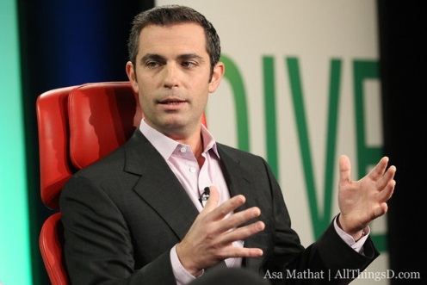
In an interview Monday with Variety, Dan Rose, Facebook’s VP of partnerships, confirmed the social-media giant is in discussions with the NFL about securing rights to live-stream games and has reached out to Hollywood agents to bring actors, athletes, music artists and others into its live-streaming fold.
Variety 3.7.16
http://variety.com/2016/digital/news/facebook-nfl-celebrity-live-streaming-deals-1201724283/

