Facebook Messenger Bots Prove a Hit for These 5 Brands
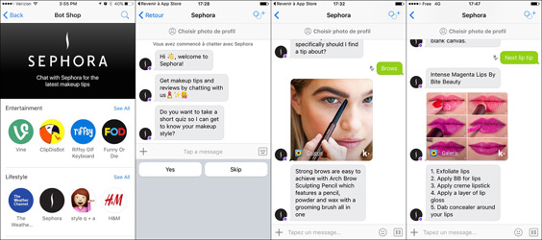
Giselle Abramovich examines 5 brands that are boosting consumer engagement on Facebook Messenger, such as Sephora, whose Reservation Assistant has boosted in-store makeover bookings by 11%, said Messenger's Stefanos Loukakos. Activision's character-driven bot for "Call of Duty: Infinite Warfare" had more than 6 million chats with fans during its first 24 hours.
CMO 12/8/17
http://www.cmo.com/features/articles/2017/10/11/5-brands-using-facebook-messenger-to-drive-engagement.html#gs.neE5=No
Image credit:
https://www.laposte.fr/lehub/IMG/jpg/sephora-2.jpg

