Facebook Plans to Increase Transparency with 1,000 New Hires
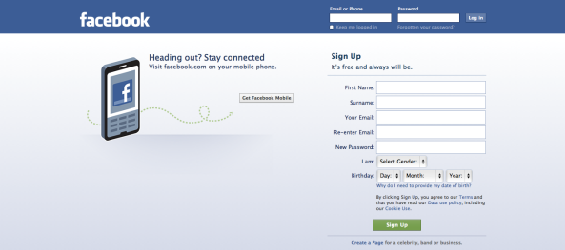
Facebook has announced that it's boosting its global marketing review unit with an additional 1,000 staff and increasing transparency by letting anyone view which campaigns are served by specific marketers on the platform. The moves follow the company handing over 3,000 ads with Russian links to US Congress, which were viewed by an estimated 10 million people, and 44% of those were seen before the presidential election.
TechCrunch 10/2/17
https://techcrunch.com/2017/10/02/facebook-will-hire-1000-and-make-ads-visible-to-fight-election-interference/
Image source:
https://idagram.files.wordpress.com/2012/12/skjermbilde-2012-12-09-kl-17-38-00.png

