Facebook Signs Celebrities, Publishers to Create Live Video
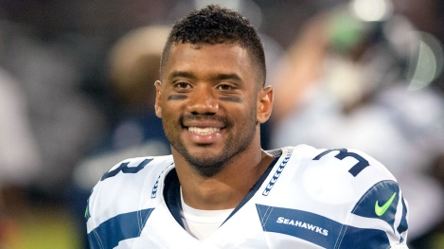
Facebook has signed deals with almost 140 celebrities and media companies to allow them to create live video content on the platform. The company is paying out around $50 million to celebrities like Gordon Ramsay and NFL quarterback Russell Wilson, as well as companies such as CNN and Vox Media.
Mashable 6/21/16
http://mashable.com/2016/06/21/facebook-live-contracts/#WMrh.T.95GqH

