Facebook to Integrate 3 Messaging Apps
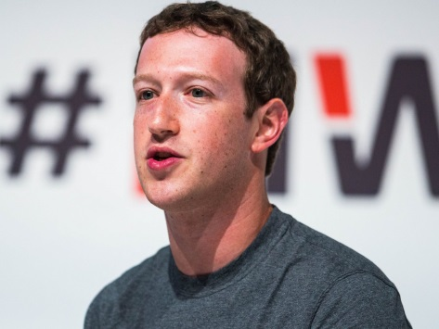
The New York Times reports that Facebook is integrating WhatsApp, Facebook Messenger and Instagram messaging by the end of this year or early 2020; the effort is being overseen by CEO Mark Zuckerberg. Messages from all three apps will be protected by end-to-end encryption.
CNET 1/25/19
https://www.cnet.com/uk/news/facebook-plans-to-merge-whatsapp-messenger-and-instagram-backends-by-2020-reportedly/
Image credit:
http://static2.businessinsider.com/image/54f83d3edd0895893d8b4655-1200-924/mark-zuckerberg-mobile-world-congress-2015-barcelona-2.jpg

