Facebook Touts New Video Tools
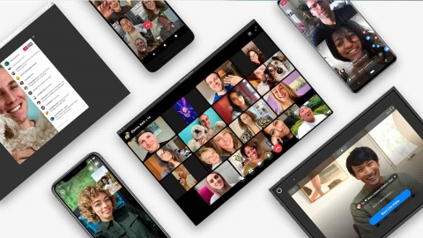
Facebook is following in the steps of increasingly popular Zoom videoconferencing service with Messenger Rooms, which enable users to start group conversations for up to 50 people, is expanding the number of people on WhatsApp calls, and is enhancing IGTV and Facebook Live with livestreaming features. R/GA's Ellie Bamford says Facebook is "fast-tracking a whole bunch of new ad units and ad models that exist within video."
Social Media Today 4.24.20
https://www.socialmediatoday.com/news/facebook-outlines-a-range-of-new-video-tools-including-messenger-rooms-for/576758/
Image credit:
https://cdn.noypigeeks.com/wp-content/uploads/2020/04/Facebook-Messenger-Rooms.jpg

