Analysis: Fake News Is A Complex, Social Condition
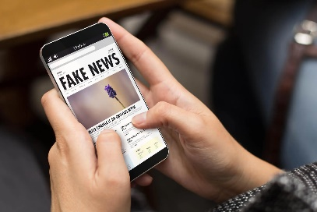
Efforts to counter false narratives and misinformation may appear to lag when results are compared against the problem, but warning labels on questionable material can positively affect readers' understanding of news stories, write Africa Check founder Peter Cunliffe-Jones and journalism professor Lucas Graves, who assert that the existence of fact-checkers can prompt political leaders to be more cautious in their claims. Misinformation is a "social condition, like crime, that you must constantly monitor and adjust to," the authors conclude.
Nieman Journalism Lab/The Conversation 1.16.24
https://www.niemanlab.org/2024/01/fact-checking-journalism-is-evolving-not-stagnating/
Image copyright:
https://i1.wp.com/www.studyfinds.org/wp-content/uploads/2019/12/AdobeStock_181605713.jpeg?fit=5184%2C3456&ssl=1

