Report: Fake Social Accounts are Impersonating Brands
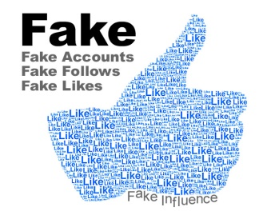
The number of bogus social media profiles created for fraudulent purposes on platforms such as Facebook, Instagram, Twitter and YouTube surged 1,100% from 2014 to 2016, ZeroFOX reports. Its study showed that about half of 40,000 fake accounts impersonated brands to entice consumers to share their personal information.
MediaPost Communications 2/16/17
http://www.mediapost.com/publications/article/295327/social-media-impersonation-exploding-with-brands.html
Image credit:
http://www.vinemedium.com.au/VineAssets/ED-Archive/Vine-Psychic-Like.jpg

