FCC Announces $412M More In ECF Awards
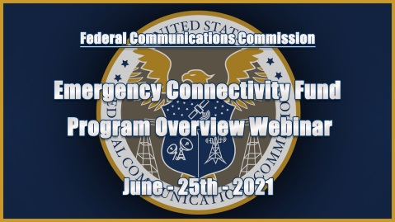
Schools, libraries and consortia collectively received $412 million for broadband access from the Federal Communications Commission's Emergency Connectivity Fund in the last wave of distribution. The ECF has given out a total of $3.05 billion so far, with New York State getting the most money and the US Virgin Islands getting the least.
Telecompetitor 11/8/21
https://www.telecompetitor.com/fcc-awards-421m-from-emergency-connectivity-fund-3-5m-broadband-connections-so-far/
Image credit:
https://i.ytimg.com/vi/jW5vUbhr5HY/maxresdefault.jpg

