T-Mobile-Sprint Deal Wins Approval From FCC
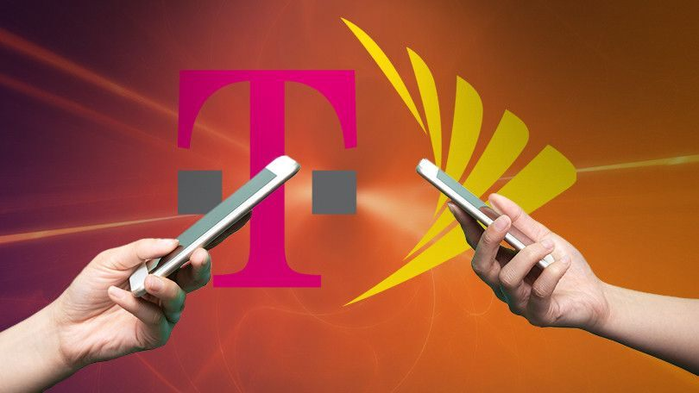
T-Mobile's merger with Sprint won approval from the Federal Communications Commission on a 3-2 party line vote with Democrats voting against the deal, an agency official said. The carriers still face a hurdle in federal court, however, where attorneys general from 17 states have sued to prevent the agreement, claiming it is anti-competitive.
CNBC 10/16/19
https://www.cnbc.com/2019/10/16/fcc-votes-to-approve-t-mobile-sprint-merger.html
Image credit:
https://techupdatess.com/wp-content/uploads/2019/07/494818-t-mobile-sprint.jpg

