FCC Approves Voluntary Rollout of Next Gen TV
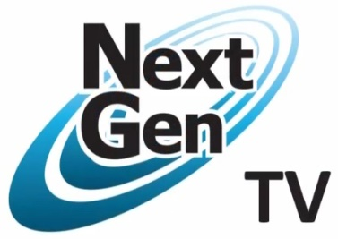
The Federal Communications Commission voted in favor of the voluntary deployment of Next Gen TV. Broadcasters are praising the move, with the National Association of Broadcasters' Gordon Smith stating, "Next Gen TV marks the beginning of a reinvention of free and local broadcast television in America."
Broadcasting & Cable 11/16/17
http://www.broadcastingcable.com/news/washington/fcc-launches-next-gen-broadcast-tv-standard/170165
Image credit:
http://www.nextgenevents.co.uk/files/images/logos/NextGen%20TV%20logo.jpg

