FCC Calls Out AT&T, Verizon for Zero Rating
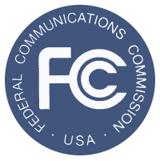
The Federal Communications Commission on Thursday sent letters to AT&T and Verizon regarding how the wireless carriers exempt their own apps from data caps. The FCC said that the "zero rating" practice can harm consumers and competition, as it can make it more expensive for internet providers to compete with those that have their own video services.
The Associated Press 12/2/16
http://www.njherald.com/article/20161202/AP/312029745#

