FCC Commissioner Warns NYC Radio Pirates Still Rampant
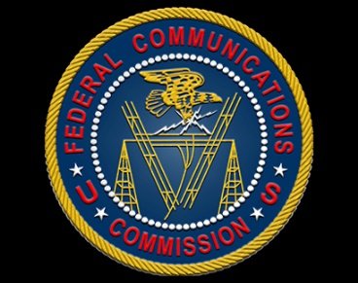
Approximately 100 to 150 unlicensed radio stations continue to operate illegally in New York City, says Michael O'Rielly of the Federal Communications Commission. The FCC recently sent warning letters to pirate station operators in New York, Pennsylvania, Florida and Connecticut, threatening fines, equipment seizures and criminal prosecution.
Inside Radio 5/28/19
http://www.insideradio.com/free/o-rielly---pirates-still-operate-in-new-york/article_345ba174-8116-11e9-bde1-2fdd5c0504da.html]

