FCC Continues Crackdown On Pirate Radio Stations
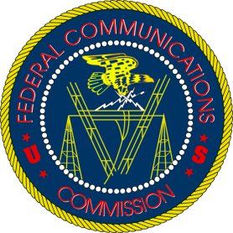
The Federal Communications Commission is continuing its efforts to shut down unlicensed radio broadcasts, and has notified property owners in New York and Michigan about suspected pirate operations on their properties. Enforcement Bureau agents have used direction-finding techniques to identify the source of unlicensed signals in several areas.
Radio World 9.12.22
https://www.radioworld.com/news-and-business/business-and-law/fcc-warns-more-property-owners-of-alleged-pirate-operations?utm_source=SmartBrief&utm_medium=email&utm_campaign=45863C53-9E40-4489-97A3-CC1A29EF491D&utm_content=66BDE3A6-54B9-40AD-9242-8942B5A76B19&utm_term=a25693a1-51b6-4112-bde4-56bd420e983f

