FCC Could Loosen Local Ownership Regs as Early as this Summer
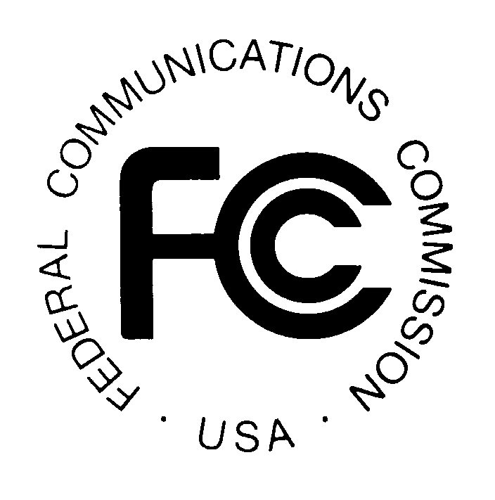
The Federal Communications Commission has set its sights on local station ownership and is reportedly expected to loosen regulations to allow ownership of two or more stations in most markets. Action could begin as soon as this summer and sources believe that the next step will be for the FCC to put petitions from Nexstar and the National Association of Broadcasters up for public comment.
TVNewsCheck 6/7/17
http://www.tvnewscheck.com/article/104733/fcc-turns-sights-to-local-station-ownership

