FCC Explores Opening More Unlicensed White Space Spectrum
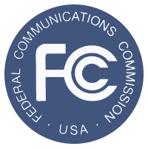
The Federal Communications Commission agreed to issue a formal proposal to provide carriers with more unlicensed white space spectrum by approving rules to permit higher towers and stronger power for cellular as well as fixed wireless services. The Notice of Proposed Rulemaking fell short of Microsoft's plea for the FCC to release spectrum near television channels, but Chairman Ajit Pai said the move would help broadband signals reach places with rough terrain.
Multichannel News 2.28.20
https://www.multichannel.com/news/fcc-boosts-unlicensed-use-of-tv-spectrum

