FCC Formally Proposes Diverting 5.9 GHz Block
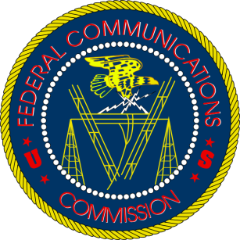
The cable industry cheered a unanimous vote from the Federal Communications Commission to press forward on a proposal to take 45 MHz from a block of 5.9 GHz spectrum reserved for carmakers and divert it to unlicensed wireless technologies such as Wi-Fi. The agency agreed to reserve parts of the remaining 30 MHz for automakers or put it all toward cellular-vehicle-to-everything technology.
Axios 12.12.19
https://www.axios.com/fcc-dsrc-chao-transportation-wifi-spectrum-0fe70f7e-711a-46ee-9cc4-e927f9bea727.html

